**TASK 1**

Processor beneath the Heat exhaust

RAM

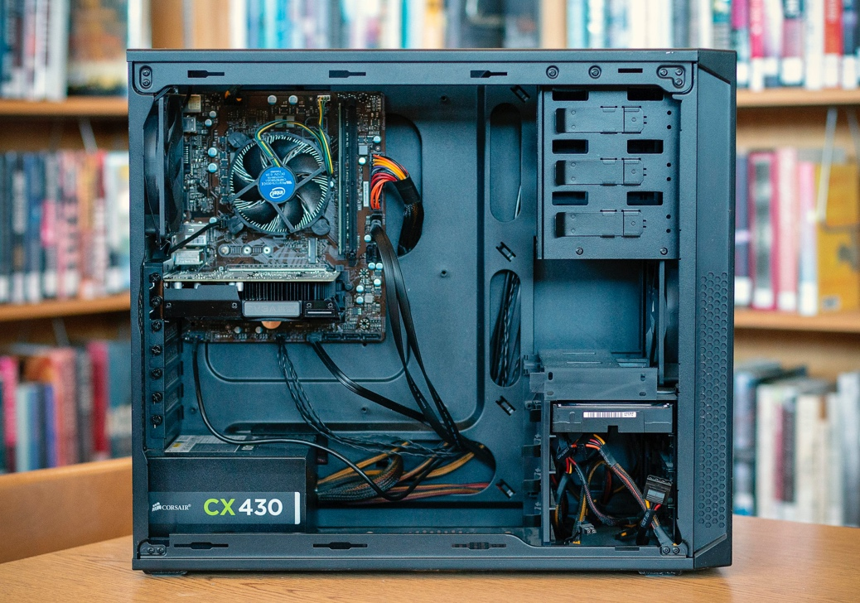

Graphics Card

Power Supply

Hard Disk

CD/DVD Drive

**TASK 2**

Name : **Using HPC to Explore the Universe**

URL : <https://developer.nvidia.com/cuda-toolkit>

Video URL : <https://youtu.be/Oz0aeL6dQGs?si=dCIyLQm4bmthEb83>

The Square Kilometre Array is a massive radio telescope which will generate about 160 GB of data every second. It will be placed in South Africa and Australia, and it aims to test cosmic mysteries, from the formation of the first stars to the nature of dark matter and dark energy. With this they also aim to test Einstein’s Theory of Relativity. This is particularly interesting as with this we can uncover how the universe came into being, and as it can answer how the first stars were created, which is quite intriguing to find out.